

Project Report
EMAIL VALIDATOR USING STRING MACHINE

STUDENT 1: Manahil Shahzad
REG NO: BCPE243049
STUDENT2: Syed Awon Muhammad
REG NO: BCPE243045

Submitted To: MR WAQAS AYUB SHAH

EMAIL VALIDATOR USING STRING MACHINE

Contents
- Introduction
- Problem Statement
- Methodologies Used
- Code
- Results
- References

1. Introduction
Email validation is a critical aspect of modern software applications, where accurate and efficient email validation ensures proper user registration, authentication, and communication. With the increasing reliance on email addresses as a method for identification and communication, validating the format of email addresses has become an essential task in many domains such as e-commerce, social media, and enterprise applications.
This project focuses on developing an Email Validator using a String Machine, which efficiently checks whether a given email string adheres to the standard structure of an email address as defined by common regular expressions (regex). The goal is to provide a simple and effective way to validate email addresses and handle various corner cases typically encountered.

2. Problem Statement
Email addresses have a specific syntax as defined by the Internet standard RFC 5321, including local parts (before the @ symbol), the domain part (after the @
symbol), and other technical rules regarding special characters, length, and acceptable characters.Validating email addresses manually or through inefficient methods can lead to errors, such as:
- Accepting invalid emails due to improper validation.
- Rejecting valid but unconventional emails due to overly strict validation patterns.
Thus, an effective and comprehensive email validation mechanism is necessary to ensure that email addresses entered by users or stored in databases are both valid and usable. This project aims to build an efficient email validator using a String Machine technique to automate and streamline the process of validation.

3. Methodologies Used
The main methodology for this project is to create a String Machine that applies a set of rules and checks to evaluate whether a given email string conforms to the expected format of a valid email address. The key methodologies used include:

a. Regular Expressions (Regex)
Regex is used to define a pattern that matches valid email formats. The following rules were taken into account while defining the regex pattern:
- The local part (before the "@") can contain letters, digits, dots, hyphens, and underscores.
- The domain part (after the "@") must contain letters, possibly separated by dots (e.g., example.com).
- There must be exactly one "@" symbol separating the local and domain parts.
- The domain must end with a valid top-level domain (TLD), such as .com, .org, .net, etc.

b. String Machine
The String Machine approach involves sequentially processing each character of the string to check if it fits within the defined regex rules. It works by scanning the
input string and validating each part according to the specific character set expected by email syntax.

c. Validation Algorithm
The algorithm follows these steps:
- Check Format: Ensure the email contains exactly one "@" symbol.
- Local Part Validation: Validate the local part of the email (before the "@") using the defined character set.
- Domain Part Validation: Validate the domain part (after the "@") for structure, such as valid domain labels and TLD.
- Edge Case Handling: Account for cases like consecutive special characters (e.g., "..") and excessively long parts.

d. Edge Case Considerations
Special care is given to edge cases such as:
- Emails with unusual domain formats or TLDs.
- Emails with invalid characters or incorrect placements of special characters.
- Proper handling of empty fields or strings.

4. Code
Here is the C++ code for Email validator using string machine :
#include <iostream>
#include <regex>
using namespace std;

// Function to validate an email address
bool isValidEmail(const string& email) {
// Regular expression for validating an email address
const regex pattern(R"(^[a-zA-Z0-9._%+-]+@[a-zA-Z0-9.-]+\.[a-zA-Z]{2,}$)");
return regex_match(email, pattern);
}
int main() {
string email;

cout << "Enter an email address to validate: ";
cin >> email;
if (isValidEmail(email)) {
cout << "The email address \"" << email << "\" is valid." << endl;
} else {
cout << "The email address \"" << email << "\" is invalid." << endl;
}
return 0;
}

5. Results
The following are the results of testing the email validator with different email addresses:
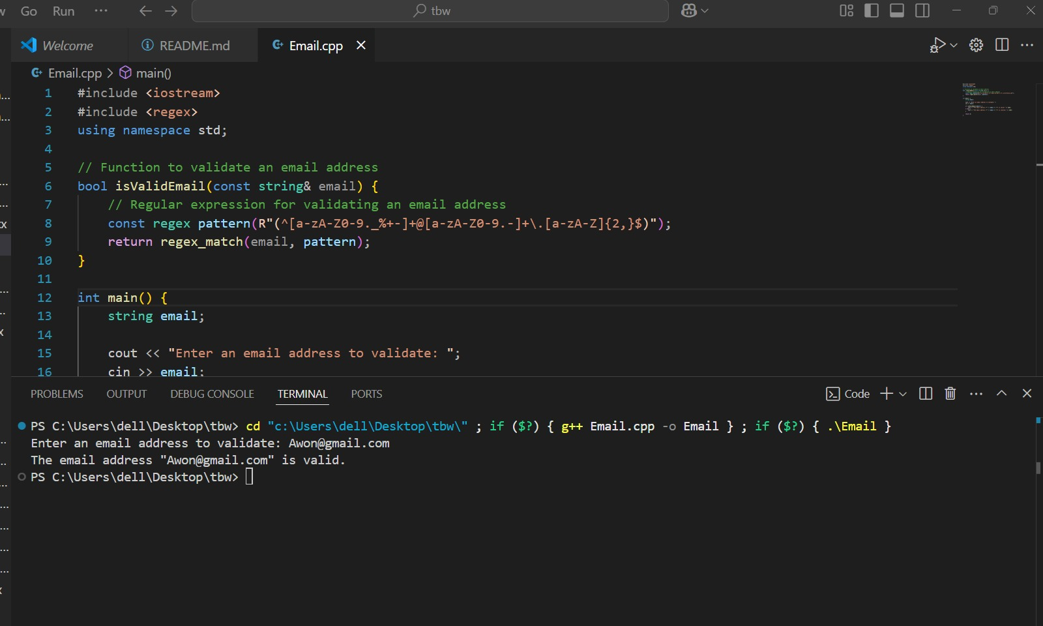

6. References
• "RFC 5321: Simple Mail Transfer Protocol," Internet Engineering Task Force (IETF), 2008.

• "RFC 5322: Internet Message Format," Internet Engineering Task Force (IETF), 2008.

• C++ Standard Library Documentation:

• C++ Programming Language (4th Edition) by Bjarne Stroustrup.

